**Intersection Data Analysis**

**Intersection Experiment Driving Patterns**

1. **Intersection Crossing**

Vehicles start from the edge of each intersection leg and move towards the intersection to cross each other.



Fig. 1: Intersection Crossing Scenario

1. **Midblock crossing**

Vehicles start from the each extreme of a certain intersection leg and move towards the midblock to cross each other.



Fig. 2: Midblock Crossing Scenario

**Region of interest**

**E**

**W**

**N**

**S**

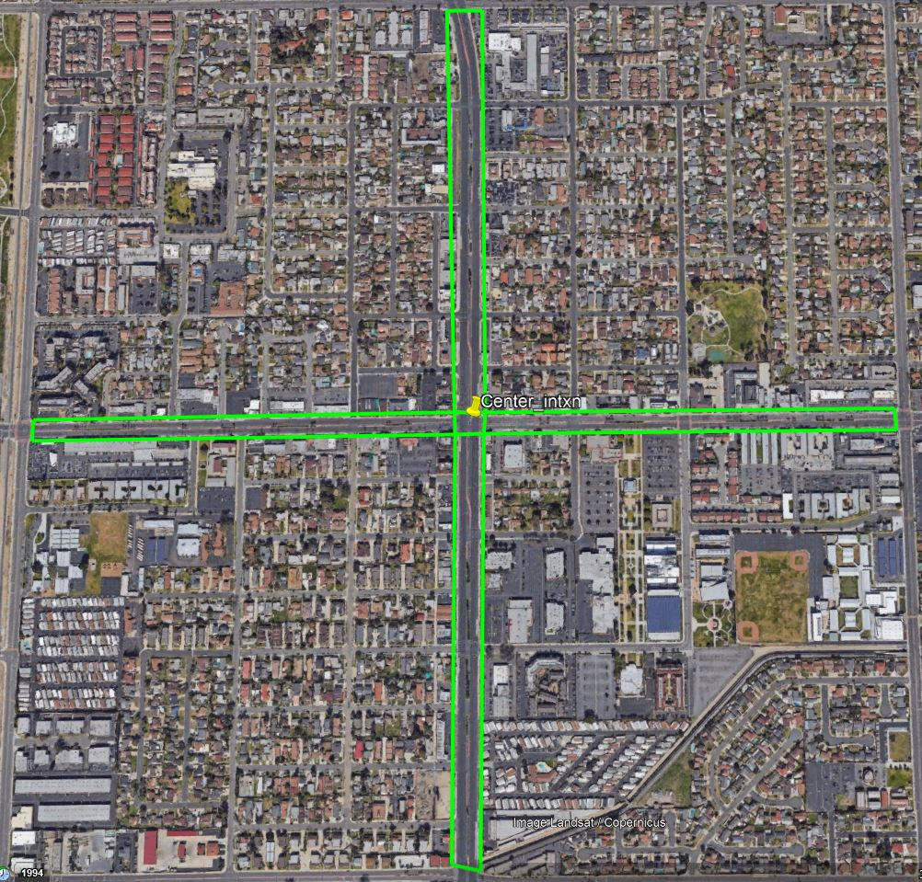

Fig. 3: Region of Interest

East Polygon

lat: [33.7595 33.7595 33.7592 33.7591 33.7595]

lon: [-117.9893 -117.9813 -117.9813 -117.9894 -117.9893]

West Polygon

lat: [33.7593 33.7595 33.7591 33.7590 33.7593]

lon: [-117.9982 -117.9899 -117.9899 -117.9982 -117.9982]

North Polygon

lat: [33.7595 33.7595 33.7664 33.7664 33.7595]

lon: [-117.9899 -117.9893 -117.9895 -117.9902 -117.9899]

South Polygon

lat: [33.7591 33.7591 33.7522 33.7523 33.7591]

lon: [-117.9899 -117.9894 -117.9893 -117.9899 -117.9899]

Center of the Intersection

lat = 33.75928266513431 lon = -117.9896472138916

**Separated Log File Column Description**

Log files are separated based on receiver position on road legs, for two different experiment types. There are 6 log files.

1. InterX_Rx_at_EastLeg.csv
2. InterX_Rx_at_WestLeg.csv
3. InterX_Rx_at_NorthLeg.csv
4. InterX_Rx_at_SouthLeg.csv
5. MidX_Rx_at_EastLeg.csv
6. MidX_Rx_at_SouthLeg.csv

|  |  |
| --- | --- |
| **Column name** | **Description** |
| Timestamp | Timestamp of the received BSM |
| RSS | Received signal strength of the BSM |
| TxRxDistance | RX-TX separation distance (straight-line distance) |
| LinkType | LOS-Same (Rx Tx at the same road leg), LOS-Ahead (Rx Tx in different straight road leg), NLOS-Perpendicular (Rx Tx in vertical road legs) |
| RxLocation | Rx position in the intersection road leg (East, West, North or South) |
| TxLocation | Tx position in the intersection road leg (East, West, North or South) |
| RxID | Receiver OBE ID |
| RxLat | Receiver latitude |
| RxLon | Receiver longitude |
| TxID | Transmitter OBE ID |
| TxLat | Transmitter latitude |
| TxLon | Transmitter longitude |
| MsgSeqNum | Message sequence number of the received BSM |
| RxDistance2Center | Rx distance to intersection center |
| TxDistance2Center | Tx distance to intersection center |
| ExpScenario | Experiment scenario (Intersection Crossing = InterX or Midblock Crossing = MidX) |